**Section Three: Comprehension**

**20% (40 Marks)**

This section has **two (2)** questions. You must answer **both** questions. Write your answers in the spaces provided.

When calculating numerical answers, show your working or reasoning clearly. Give final answers to **three** significant figures, unless specifically instructed to calculate the correct significant figures. Include appropriate units where applicable.

When estimating numerical answers, show your working or reasoning clearly. Give final answers to a maximum of **two** significant figures and include appropriate units where applicable.

Supplementary pages for the use of planning / continuing your answer to a question have been provided at the end of this Question / Answer booklet. If you use these pages to continue an answer, indicate at the original answer where the answer is continued, i.e. give the page number.

Suggested working time: **40 minutes**

_________________________________________________________________________

**Question 23**

**(20 marks)**

# Neutron star collisions create huge magnetic spikes

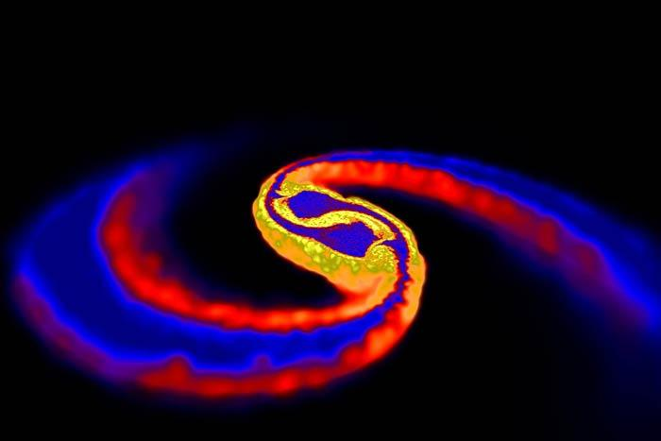

The strongest magnetic fields known in the Universe are produced when a pair of extremely dense and compact stars merge. The first computational model has been devised of such an event that takes magnetism into account. The model begins with two cold neutron stars in a circular orbit around each other, and both with masses 1.4 times that of the Sun. Comparative masses can be seen in Table 1.

When their orbits decay and the two stars collide, they merge to form a single object incredibly quickly - within about 2 milliseconds. Spiral arms then form off the central object and, at the point of intersection; instability causes the two stars' magnetic fields to curl into vortex rolls.

Previous work had suggested that merged neutron star remnants might collapse under their own weight to produce black holes before being able to produce a big magnetic spike. But the collapse is estimated to take at least 100 milliseconds, and the new data suggests an extremely short timescale for the amplification of the merged object's magnetic field, showing the spike should occur in reality.

|  |  |  |  |  |  |
| --- | --- | --- | --- | --- | --- |
| Table 1: Comparative masses of known entities in the Universe. | | | | | |
| **object** |  | **mass** | **radius** |  |
| the sun |  | 1.99 × 1030 kg | 696,000 km |  |
| white dwarf star |  | 0.5 to 1.4 solar masses | 5000 km |  |
| neutron star |  | 1.4 to 3 solar masses | 10 km |  |
| stellar black hole |  | more than 3 solar masses | 2*Gm*/*c*2 (event horizon) |  |
| super massive black  hole |  | > 106 solar masses | 2*Gm*/*c*2  (event horizon) |  |
| the known universe |  | 1053 kg | 13.7 × 109 light years |  |

(Table adapted from http://hypertextbook.com/physics/matter/density/)

1. Neutron stars are the remnants of huge stars that have exploded as supernovae. The neutron star mentioned in Paragraph 1 has a radius that is only of the order of 10 km. Such a dense object has very high gravitational field strength at its surface.
2. The density of an object is given by its mass divided by its volume:

Density (ρ) = Mass (m) / Volume (V).

For a spherical star of average density *ρ* , the magnitude of *g* at its surface is given by:

**g = 4/3 G π r ρ**

where G is the universal gravitational constant

Use these expressions to show that the units of g are N kg-1 **(3 marks)**

1. The volume of a sphere is given by the expression

V = 4/3 Π r 3

Use this expression, the formula in part (i) and information in Table 1, to **ESTIMATE** the gravitational field strength at the surface of the neutron star. (**5 marks)**

1. A remarkable property of neutron stars is that they spin about their axes at a very great rate. The radiation from these stars is observed as regular pulses. This gives rise to the name 'pulsars'. This particular neutron star of radius 10.0 km rotates 50.0 times every second.
2. Show that the speed of a point on the equator of the star is approximately one percent (1%) of the speed of light.  **(3 marks)**
3. Calculate the centripetal acceleration at a point on the equator of the star.

**(3 marks)**

Below is astronomical data that you may find useful when answering the following question.

|  |  |
| --- | --- |
| mass of Cassini = 2.20 x 103 kg | diameter of Saturn = 1.21 x 108 m |
| mass of Jupiter = 1.90 x 1027 kg | Saturn day = 10.7 Earth hours |
| mass of Saturn = 5.70 x 1026 kg |  |

1. Calculate the magnitude of the total gravitational field strength experienced by Cassini when it is 3.90 x 1011 m from Saturn. **(2 marks)**
2. The Earth has multiple satellites orbiting it at any point in time. The centripetal force required to keep the satellites in orbit is provided by the Earth's gravitational field. Use this fact to derive an expression for the orbital radius, r, for the satellite, let:

G, the gravitational force constant

*r,* the radius of orbit of the satellite

*v,* the speed of the satellite in its orbit

ME, the mass of the Earth

MS, the mass of the satellite

**(2 marks)**

1. A telecommunications satellite needs to be placed at a certain height above the surface of the Earth, at the equator, so that it remains in geosynchronous orbit. Calculate the orbital radius of the satellite.

**(2 marks)**

**Question 24**  **(20 marks)**

**Determining the Magnetic Field Strength (B) of a Horse-shoe Magnet**

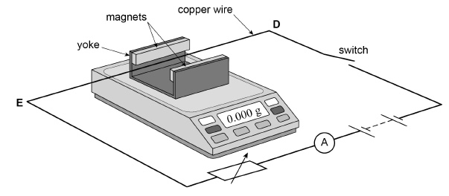



Students performed an experiment to calculate the magnetic field strength (B) of a horse-shoe magnet.

The equipment was set up as shown in the photograph. The diagram shows the configuration of the circuit. The horse-shoe magnet was placed on the mass balance and the mass balance was tared. (Set to read 0g) The current carrying conductor was stretched tightly and clamped in place such that it was unable to move.

The current through the conductor was varied and the reading on the mass balance noted. The results are displayed in the table below.

|  |  |  |
| --- | --- | --- |
| Current (A) | Change in Mass Δm (g) | Force (N) |
| 0 | 0 |  |
| 1.0 | 0.18 |  |
| 2.0 | 0.33 |  |
| 3.0 | 0.53 |  |
| 4.0 | 0.76 |  |
| 5.0 | 0.97 |  |

1. The direction of conventional current in the photograph above is left to right. Annotate the north and south pole of the magnet on the photograph above.

**(1 mark)**

1. Explain using relevant **mathematical relationships / formulae** how this experimental setup can be used to calculate the magnitude of magnetic field strength of the horse-shoe magnet.

**(2 marks)**

1. Complete the table above by filling in the values for force. **(2 marks)**
2. The photograph is 50% the size of the real equipment. Use the photograph, and this information to measure the length of the conductor in the magnetic field. **(1 mark)**

Length of conductor in magnetic field = __________________

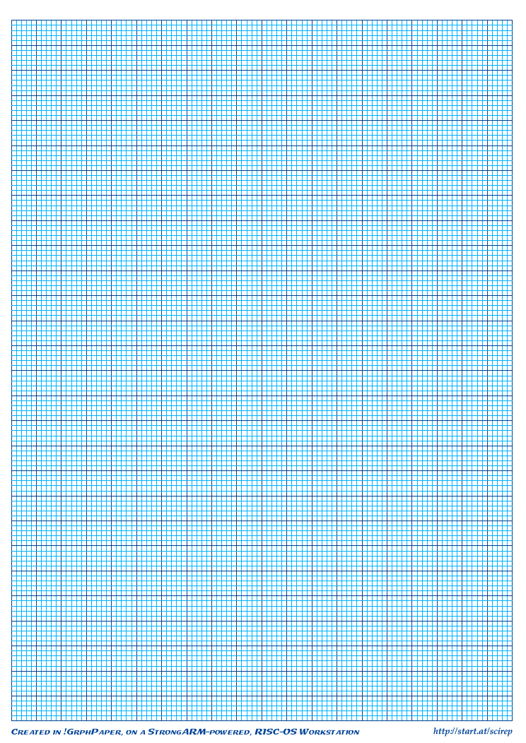

1. Use the mathematical relationship you’ve described in part (b), and the information you calculated in (c) to **draw a graph** which will allow you to calculate the magnetic field strength of the horse-shoe magnet. Don’t include error-bars. **(4 marks)**
2. **Use the graph** to calculate the magnetic field strength of the horse shoe magnet. Clearly show all working**.** **(4 marks)**
3. For the fourth data point only (Balance reading = 0.53g; Current = 3.0A), calculate the value for magnetic field strength and its associated uncertainty. **(4 marks)**
4. Error bars should be included for all points on your graph. However, as they are very small they are difficult to display accurately at graph scale. For the **fourth data point only** (Balance reading = 0.53g; Current = 3.0A), display the error bar associated with **this point only** by drawing a magnified version of this point in the graph paper below. **(2 marks)**



**END OF EXAM**

Acknowledgements

Question 23 New Scientist, March 2006 by [Kimm Groshong](http://www.newscientist.com/search?rbauthors=Kimm+Groshong) ; Journal Reference: *Science* (DOI: 10.1126/science.1125201)



